

INTERNSHIP REPORT

PREPARED BY:

Ijaz khan
FA21-BAF-046

Table of Contents
ATTESTED COPY OF INTERNSHIP/JOB LETTER 3
BUSINESS CARD OF TERRITORY MANAGER 4
BUSINESS CARD OF BUSINESS DEVOLOPMENT MANAGER 4
Introduction: 7
Company Background: 7
Organizational Structure 9
Product and Services offered. 9
SWOT Analysis 10
Strengths 10
Weaknesses 11
Opportunities 11
Threats 11
Learning Experiences 12
Week 1. 12
Route 4 Visit. 12
Week 2. 13
Route 1 Visit: 13
Week 3. 15
Route 5 visit: 15
Week 4 16
Route 6 visit: 16
Week 5 18
Route 11 Visit: 18
Week 6: 19
LMT Visits With BDM: 19
Details of Overall Distribution: 21
Other Activities 21
Personal Learning 25
Conclusion: 25
Recommendations 25

ATTESTED COPY OF INTERNSHIP/JOB LETTER

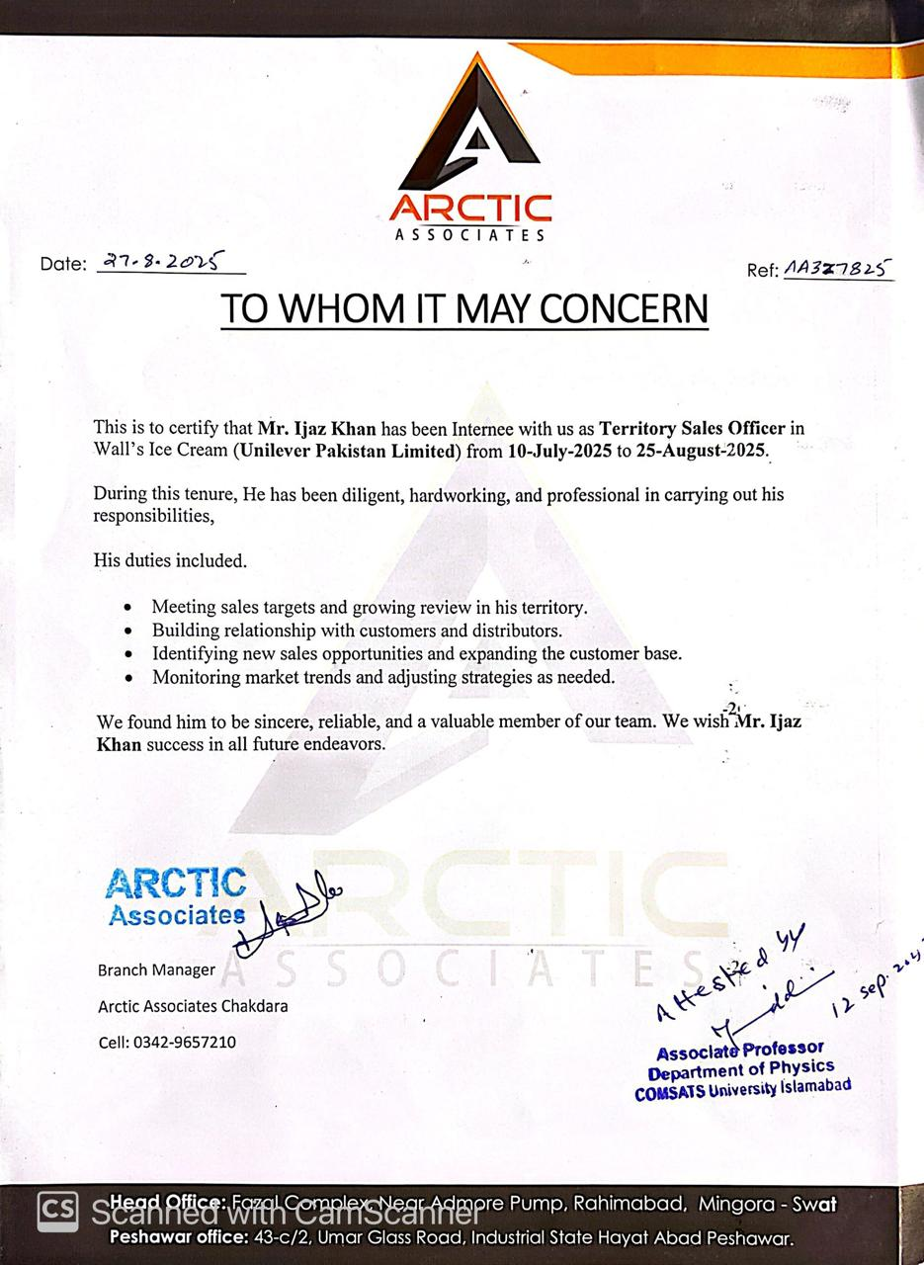

BUSINESS CARD OF TERRITORY MANAGER

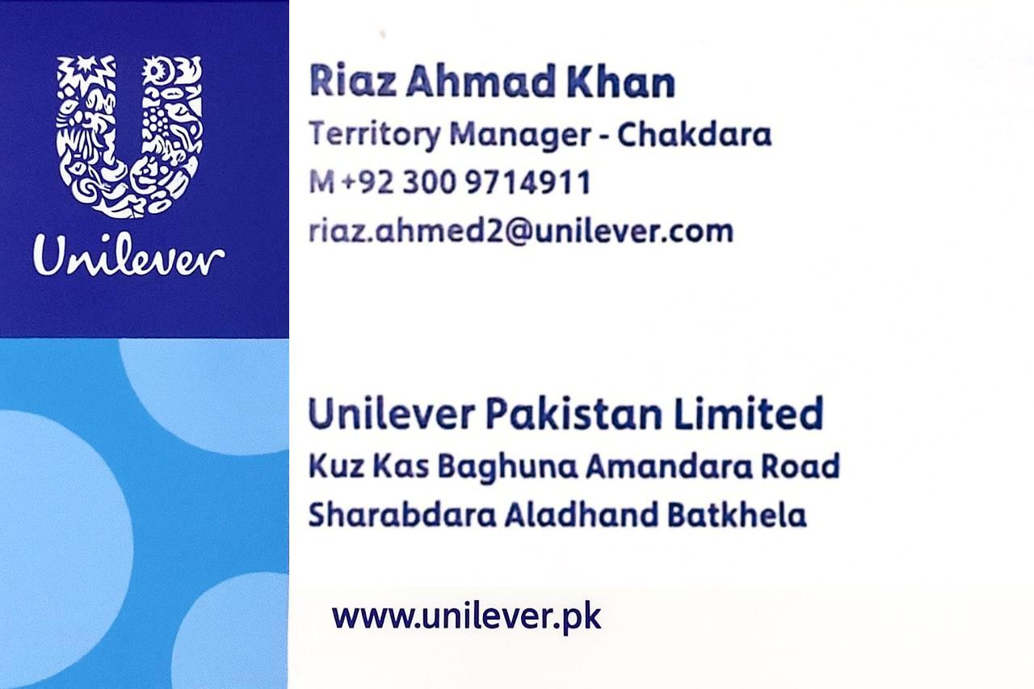

BUSINESS CARD OF BUSINESS DEVOLOPMENT MANAGER

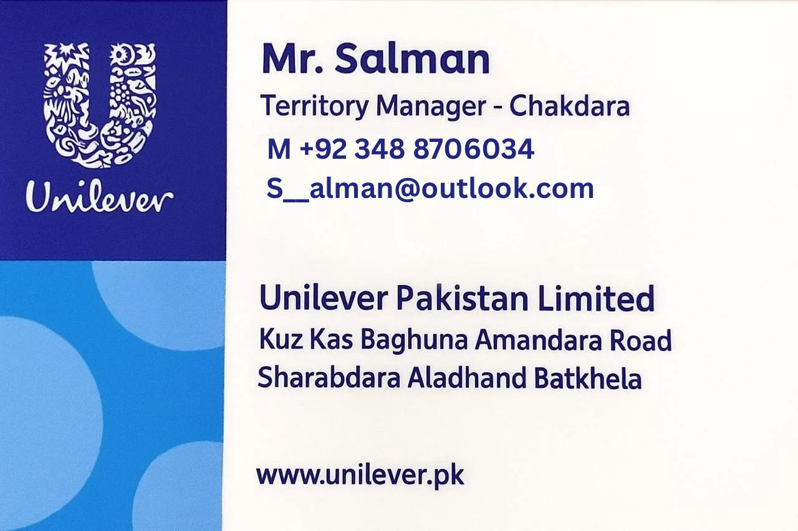

PLAGIARISM REPORT OF TURNITIN

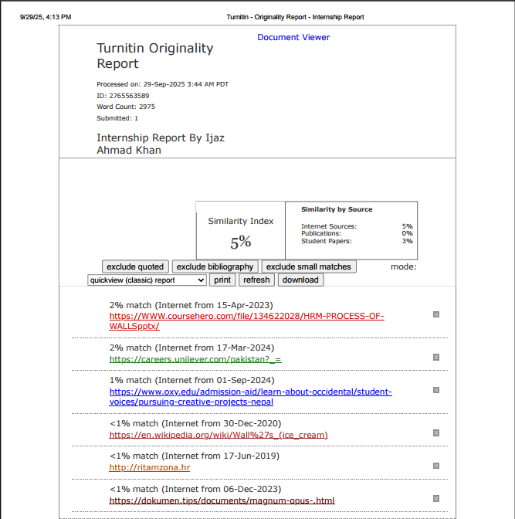

- Executive Summary:
My internship offers a comprehensive description of my marketing and sales experience as Territory Sale Officer (TSO) at Unilever Wall's at Arctic Associates3. The report opens with an overview of the internship program's selection process, highlighting the multi-step process used to obtain a spot in the program. The Organization's goals are outlined, with a focus on streamlining Sales performance and Targets Achieving with different strategies of sales and marketing experiences. I had the chance to learn a lot about the marketing industry during my Six-week internship at Unilever Wall's at Sales Department As a as Territory Sale Officer (TSO) and put my academic knowledge and skills to use. The experience included a variety of jobs and pursuits that aided in my development both personally and professionally. My learning and experience during the internship period are elaborated upon. The tasks performed, including Team leading, Minutes of JC meeting, Market Visits of different Routes, Doing Missing Agreement, TTS Shops target Achieving, NFC Scanning of Assets, Critical thinking and problem solving, Customer satisfaction, Sharing Target with RSOs, Customer satisfaction and problem solving of different Retailers shops.

Introduction:
I am reporting my internship and the period at Unilever Wall's at Arctic Associates3. I was Appointed as A Territory Sale Officer (TSO). It was a two steps procedure. First, I had Apply for the Vacant Position, secondly, I Appeared for interview to Territory Manager of Unilever Wall's. I started on 10th Jully 2025 and ended at 25th August 2025.
Unilever Pakistan is working from 70-year- from the era as our country become independent. Including our inner and outer core, Unilever Pakistan is a growing family of 20,000 + citizens and have a diverse portfolio of over 25 brands of multiple categories. The brands in the local portfolio include Walls, Surf Excel, Lux, Knorr, Glow & Lovely. They keep in with the lives of almost two hundred million consumers.
Wall's is part of Unilever's Heart brand family of ice creams that are sold in more than forty countries around the world under many different local names, including Algida and Ola. Among its products are ice creams that are lower in fat and sugar, and enriched with fruit and calcium, which have been developed through the brand’s innovative food technologies.

Company Background:
Unilever Walls Pakistan is a well-known brand in the ice cream market, operating under the umbrella of Unilever, one of the world’s largest consumer goods companies. It was Established in Pakistan in 1997, Walls captures the overall Ice cream market, Famous for its vascular range of high-quality and innovative ice cream SKUs. The brand is delivering joy through its diverse offering’s SKUs, Focusing to all age groups and preferences.
“As part of Unilever’s global Objective, Walls Pakistan emphasizes justifiable business practices, focusing on minimizing its environmental impact and promoting corporate social responsibility. The hallmark also maintains strong emphasis on quality, safety, and consumer satisfaction, ensuring its products meet the requirement good standards. With its vast distribution network and have grab on marketing presence, Walls Pakistan continues to be an authoritative in the frozen desserts market, presenting happiness towards millions of consumers over the country.” (https://en.wikipedia.org/wiki/Wall%27s_(ice_cream))

Vision:
Unilever Walls' vision is centered around spreading happiness and delight through its high-quality ice cream products while maintaining a strong Commitment to sustainability. As part of Unilever’s global vision of "making sustainable living commonplace," Walls seeks to deliver joy to consumers while ensuring that its operations and supply chains contribute positively to the environment and society. The brand aims to provide affordable, innovative, and delicious ice cream options to all, while reducing its carbon footprint, minimizing waste, and supporting responsible sourcing practices. Walls envision a future where indulgence and sustainability go hand in hand, ensuring a better world for both current and future generations.

Mission Statement:
“The mission of Unilever Walls Pakistan is to bring happiness and delight to consumers by offering high-quality, innovative, and affordable ice cream products that cater to diverse tastes and preferences. Aligned with Unilever’s broader Commitment to sustainable living, Walls Pakistan is dedicated to minimizing its environmental impact through responsible sourcing, reducing waste, and promoting sustainability across its operations. The brand strives to create moments of joy while ensuring a positive contribution to society, the environment, and the communities it serves.”

Organizational Structure

The culture of Unilever Walls (Arctic Associates3) is open and flexible. All the employees share the same sitting arrangement and enjoy mutual respect from each other. The leadership is easy to approach. The TM, Mr. Riaz Ahmed Khan, has maintained a friendly and open environment. His helpful and understanding nature can be seen in other managerial personnel. The friendly and approachable culture not only prevails within the Department but also exceeds other Departments as well. People are always ready to help wherever they can. The structure includes TM and Following…

- Territory Manager (BDM)
- Business Development Manager (BDM)
- Territory Sale Officer (TSO)
- Route Sale Officer (RSO)
- Delivery Boys (DBs)
- Transport In charge

Product and Services offered.

  - Cabinet Deployment.
  - Regular visit Of RSO
  - Advertisement of Products
  - Sign Board, Dustbins, Benches at different Tourism Spots.
  - On Time Delivery.
  - Product Display Card Are Attached here.

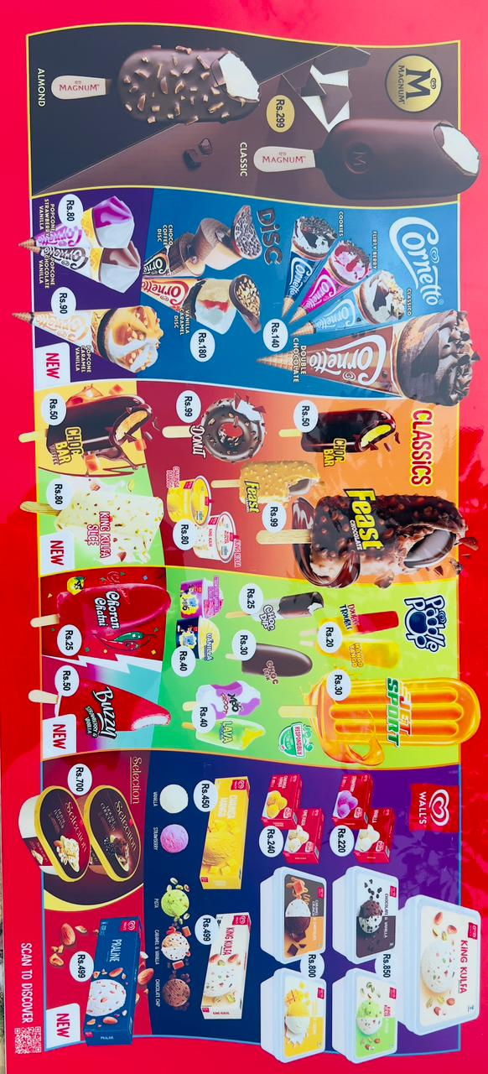

SWOT Analysis

Strengths
  - Effective Marketing strategies
  - Famous Brand
  - Diverse Range of Products
  - Promo Discounts
  - Expert Sales Team
  - Assets With the retailer
  - Easy access of retailer to BDM
  - On Time Delivery Service

Weaknesses
  - Shortage Of low budget Stocks
  - Items Easily copied by Local Companies
  - Regional inefficiency of cold rooms
  - Not serving Desserts of Dairy Products.
  - Electricity Issues throughout the country

Opportunities
  - To Launch Ice-lolly (Hajmola) Slogan Based digestion purpose.
  - Launching dairy Products to Beat HICO brand
  - Solar Panels to overcome Electricity Issues
  - Market Growth
  - Expansion of cultural activities to trap Customer.

Threats
  - Low Budgeted Stocks space occupied by Local ice-cream.
  - Popularity Of local brands
  - Economic and political situation of the country

Learning Experiences

Week 1.

Route 4 Visit.
On my Day1 of the first week, I visit with the RSO Mr. Hamid-Ullah visit his all section according to the tracking sheet. According to my JD supervising the RSO focusing on productivity, service level, maintaining planograms of the different SKUs and noticing all the issues and problems of the retail shops reporting them to BDM and finding out the solutions to the problems and satisfying the customer. Also look at the situation of freezer, focusing on finding out that is the retailer keeps any local stocks of other company in walls cabinet. Missing agreements were also made and handover to BDM. And the rest of the other days of the 1st week complete the visit of the overall section of different days. Snapshots of the tracking sheet are attached here.
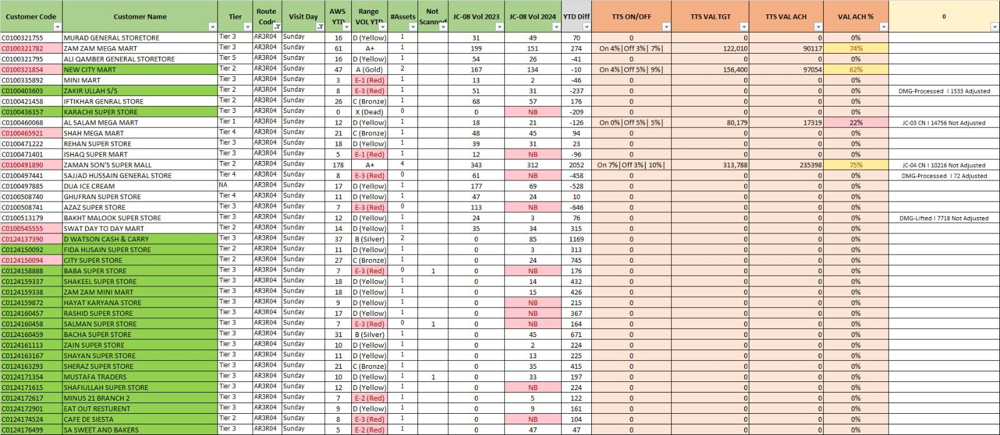
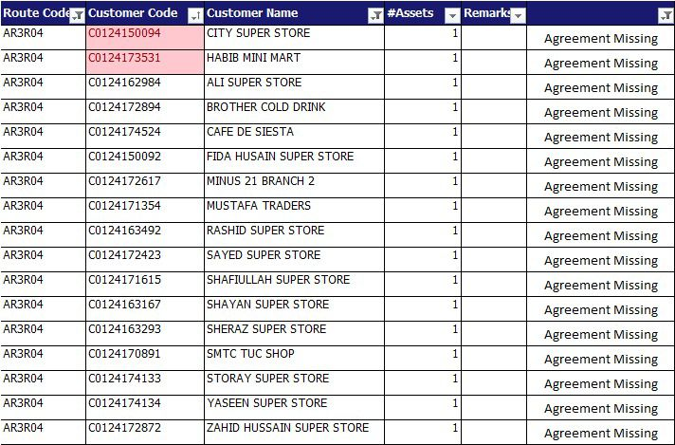
Details of missing Agreements of route4 are attached here.

Week 2.

Route 1 Visit:
On my 2nd week I start visiting with the RSO Mr. Gul Muhammad Khan by following order of The BDM visit all sections of Route 9 according to the tracking sheet. According to my JD supervising the RSO focusing on productivity, service level, maintaining planogram of the different SKUs and noticing all the issues and problems of the retail shops reporting them to the BDM and finding out the solutions of the problems and satisfying the customer. There Were multiple of problems founds in Route9 like the RSO were not giving proper time to the customer and have non serious attitude with the shopkeeper So Warned the RSO to confirm their visits and give the ideal time to the Market. Also look at the situation of freezer, focusing on finding out that is the retailer keeps any local stocks of other company in walls cabinet. Missing agreements were also made and handover to TM. and rest of the other days of the 2nd week complete the visit of the overall section of different days. Snapshot of the tracking sheet are attached here…
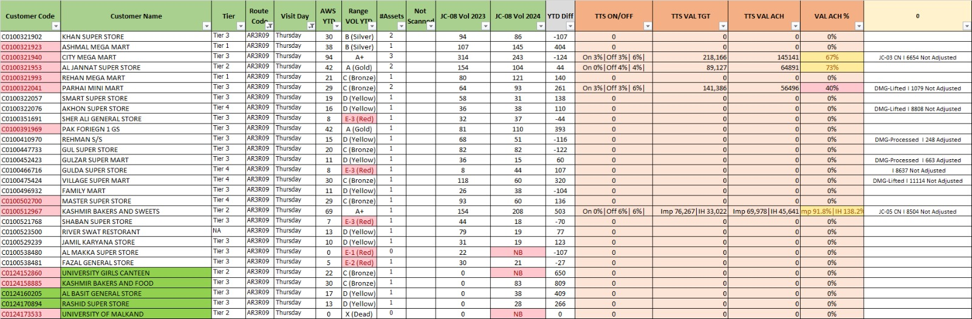

Missing agreement Detail are attached as a snapshot.

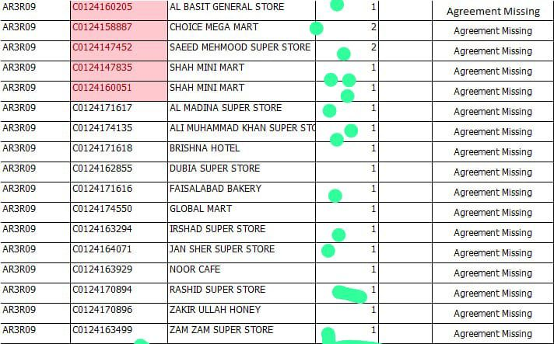

Week 3.

Route 5 visit:

I actively participate in the 3rd week start visiting with RSO Mr. Kashif khan meeting all the Retailers of all sections of Route 4 according to the tracking sheet. According to my JD supervising the RSO focusing on target achieving, productivity, service level, maintaining planogram of the SKUs and noticing all the issues and problems of the retails shops and highlighting the BDM, finding the solutions of the problems, and satisfying the customer. A slight problem was found in Route5 like the RSO were not properly managing and distributing shorts stocks to the demanding customer. Also look at the situation of freezer, focusing on finding out that is the retailer keeps any local stocks of other company in walls cabinet. Also found that some shopkeepers were treating misbehavior with the RSO so sort out the problem there on the spot and convince the relevant person. Missing agreements were also made and handover to TM. and the rest of the other days of the 3rd week complete the visit of the overall section of different days. Snapshot of the tracking sheet are attached here…
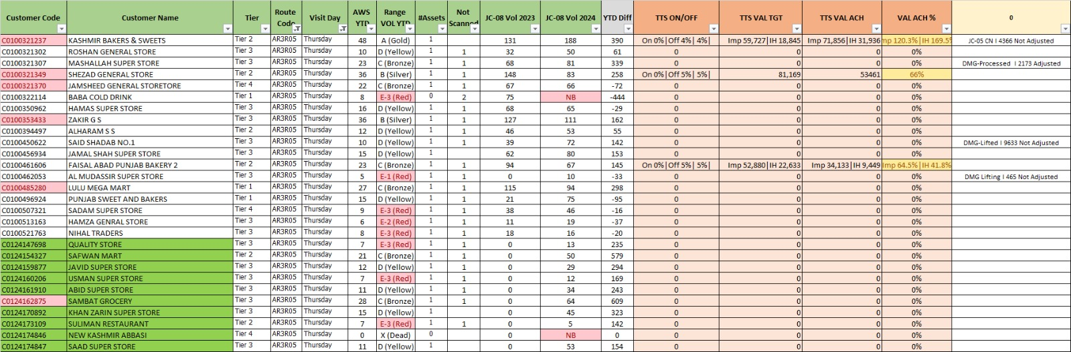

Missing agreement details.

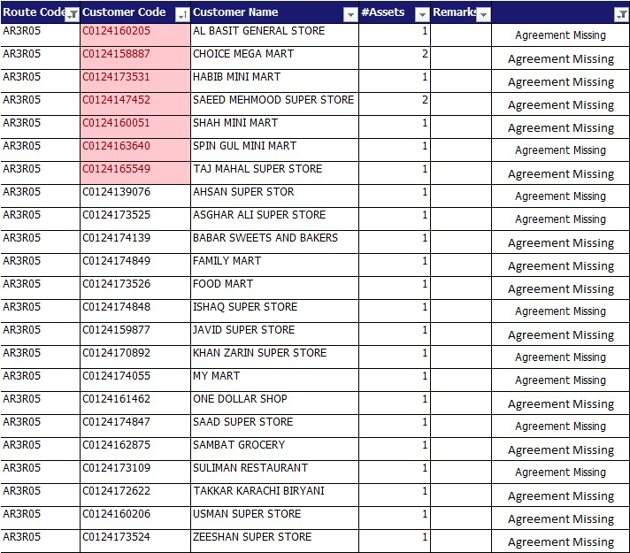

Week 4

Route 6 visit:
On my 4th week of internship, I start visiting with RSO Mr. Wajid Khan meet all the Retailers of all sections of Route 6 according to the tracking sheet. According to my JD supervising the RSO focusing on target achieving, productivity, service level, maintaining planogram of the SKUs and noticing all the issues and problems of the retails shops and highlighting the BDM, finding the solutions of the problems, and satisfying the customer. A problematic retailer was found in Route 6 like the retailer did not allow the RSO to click before and after pictures which were mandatory for all RSO`s. So convinced the retailer to cooperate with the Respected RSO`s. Also look at the situation of freezer, focusing on finding out that is the retailer keeps any local stocks of other company in walls cabinet. Some local stocks were found in the freezer, which is not allowed, so warned Also lift some of the cabinet from the retailer. The missing agreements were also made and handovers to the TM. and the rest of the other days of the 4th week complete the visit of the overall section of different days. Snapshot of the tracking sheet are attached here…
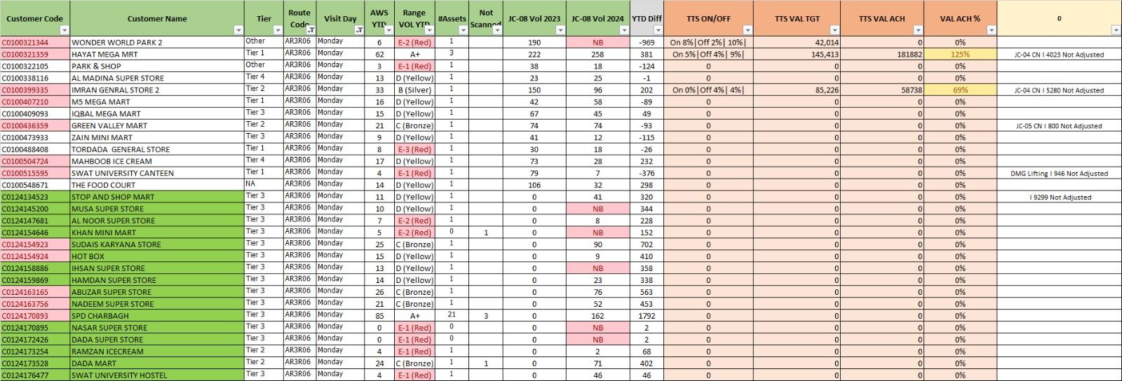

Missing agreement details are attached here:
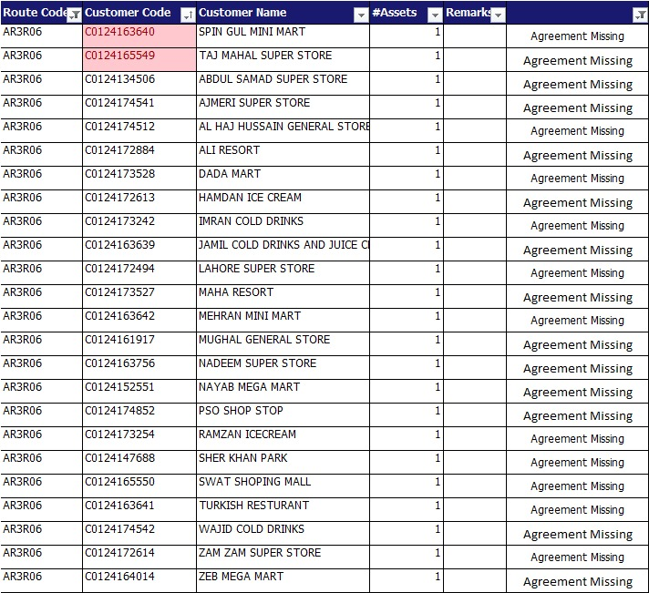

Week 5

Route 11 Visit:
I honed my critical thinking abilities and learned effective problem-solving strategies, which are essential for marketing strategy development. As per routine I start visiting Route 1 with RSO Mr. Aizaz Khan and noticing all the issues and problems. All the cabinets were lifted by the RSO from the retailers who were selling regularly local stocks in the cabinet. Also analyze and focus on productivity, service level, maintain planogram of the different SKUs and noticing all the issues and problems of the retail shops reporting them to the BDM and finding out the solutions to the problems and satisfying the customer. Also look at the situation of freezer, focusing on finding out that is the retailer keeps any local stocks of other company in walls cabinet. Missing agreements were also done and handing over it to TM. And the rest of the other days of the 5th week complete the visit of the overall section of different days. Snapshots of the tracking sheet are attached here.

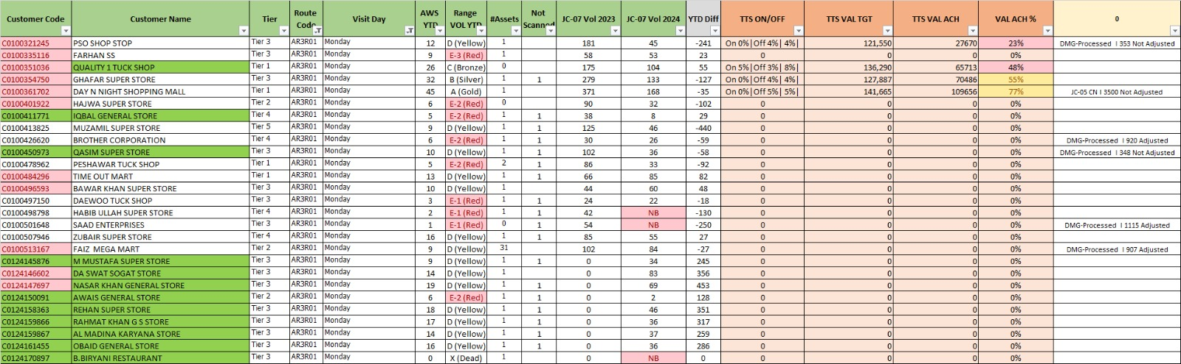
Missing Agreement Details…

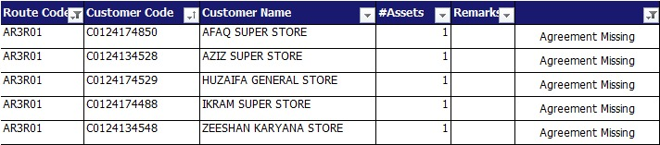

Week 6:

LMT Visits With BDM:
I gained insights into the practical aspects of visiting BDM Salman Ahmed. In the start of week 6^{th,} we start visiting with BDM of different Local Modern Trade analyze with different strategies of sales & marketing. Also visits to different hotels, restaurants, & cafes and orienting them in the ice-cream business to give growth to the company that hits different competitors. All the week we visited multiple spots, a few of them I am mentioning here Unique kitchen, Chaye Khana in Swat, Rooftop Café, Vintage Home, SA sweets & bakers etc. In this week I learned a lot from BDM like how to deal with LMT, how to convince customers and attract them towards the brand. Also boosts my skills of handling problematic customers. Also get opportunities to learn more about FMCG knowledge.
E1, E2 & E3 Range shops visits.
E1 range customer are those who have very low sales on weekly basis and there contribution was in the red line and keep on going for both customer & company was analyzed that both are in loss, company send a list if those and give them a special trade offer buying of specific amount so they will get trade offer or either instruction was to lift the cabinet so week 9&10 list of the shops was given and start visiting to these shops.
E2 range customers also showed a low contribution in sales but E2 range shops are little better than E1 so company gives them exclusive offers to speed up the sales of specific customers.
E3 range customers also showed a low contribution in sales but E3 range shops are better than E1 & E2 so company give them special trade offer to speed up the sales of specific customers and to shift D or C range customers. Some Glimpse of E1 E2 & E3 range are shown here.
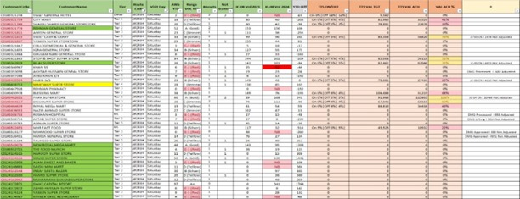
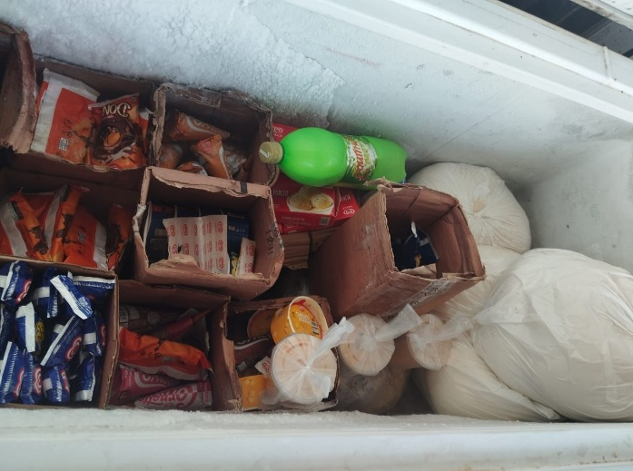
Some Glimpse of Visiting E Range Shops:

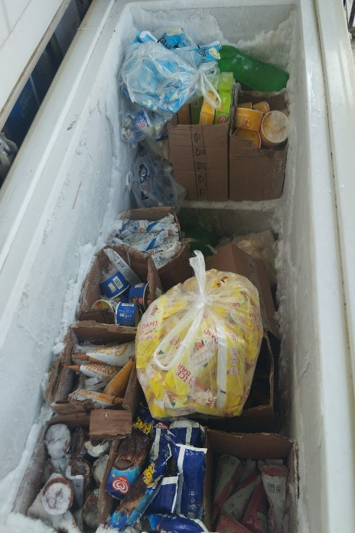

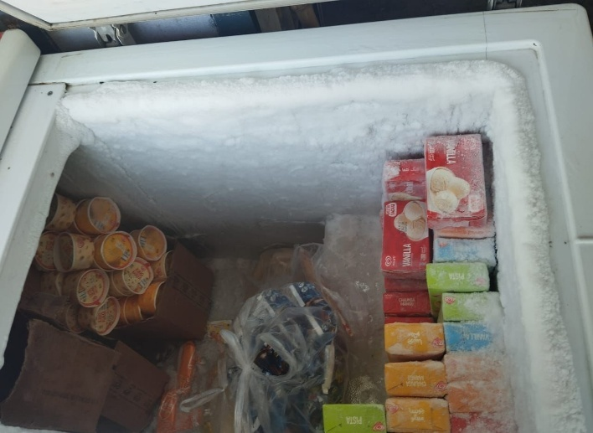

Details of Overall Distribution:
I was supervising the sales team of Unilever Wall`s. The overall Team is managed by Riaz Ahmed khan (Territory manager) while other business development process managed by Salman Ahmed (Business Development Manager).

Other Activities
The details of these tasks and my personal gain from these tasks are given below.
Discussion Of Timestamping.
Every Morning there was meeting with RSO`s and discussing Previous day report like how productive it was, how much he spends time at different shops, how much their daily sale report was, basis on these data planning for achieving target based on data. And ask the RSO`s for any lifting plan or any other issues regarding market. Snapshot of the time stamping are attached here…
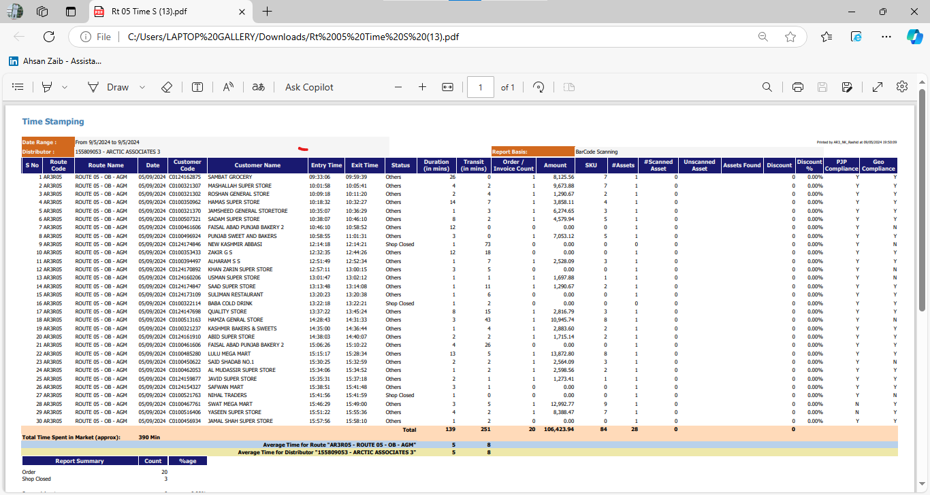

Daily Morning Meeting:
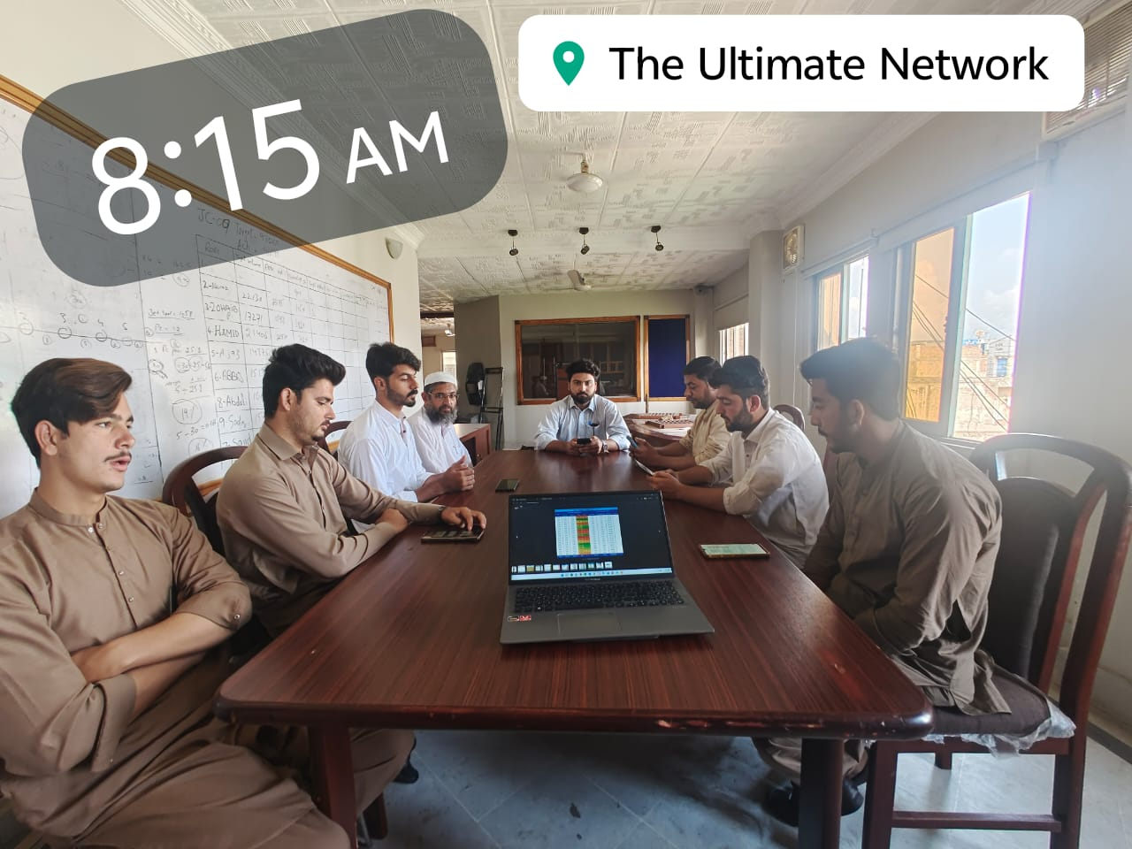

Microsoft Excel Skills:
Through working with Excel sheets, I gained proficiency in data management, Staff attendance and reporting cabinet lifting plan, damages details of retailer which are valuable to my career.

Target Achievement.
Starting of Every JC have different monthly target of Both TSO`s, the TSO then Distributing the target on every RSO according to the sensitivity of the Route and then planning for achieving the target.
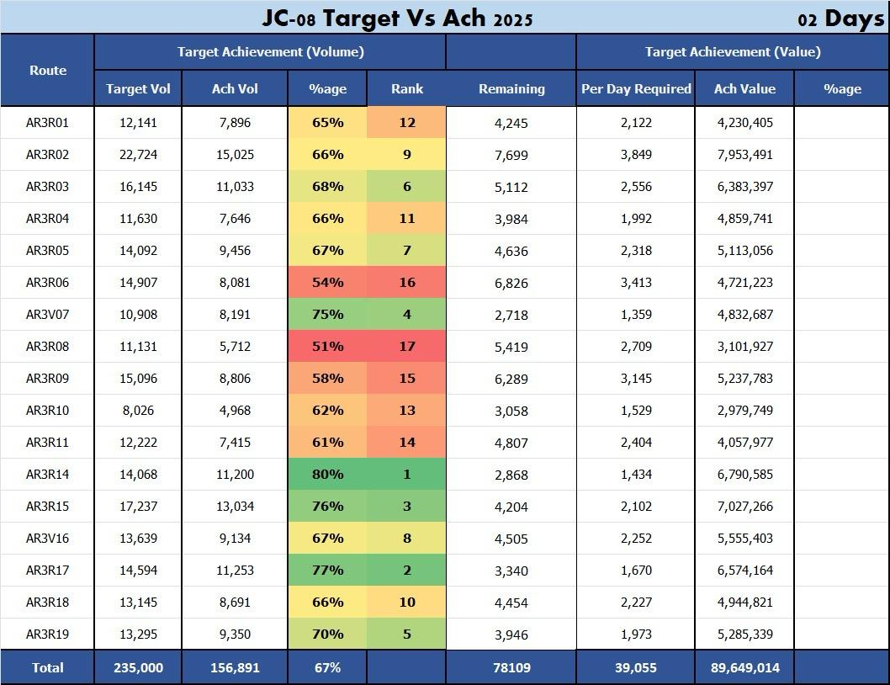

Critical Thinking and Problem Solving: The training in critical thinking and problem-solving sharpened my analytical abilities, which are important for marketing strategy sales promotion and right decision- making at right time.

NFC Scanning of Assets.
In Every JC there was a scanning cycle of company assets for ensuring the presence of assets at the spot of the retail shop.
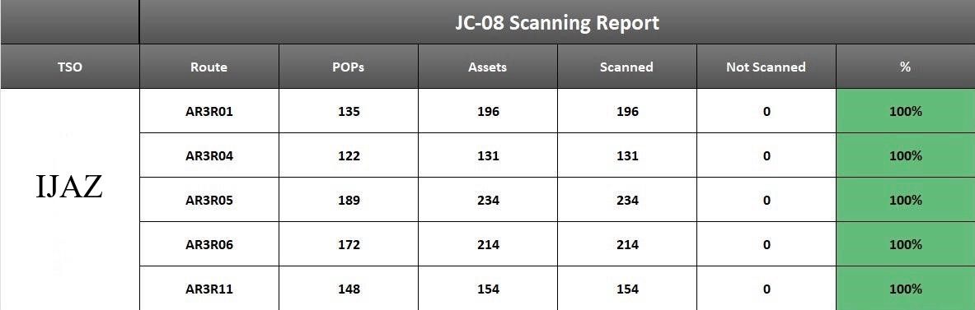

JC Meeting with the Territory Manager Mr Riaz Ahmad:
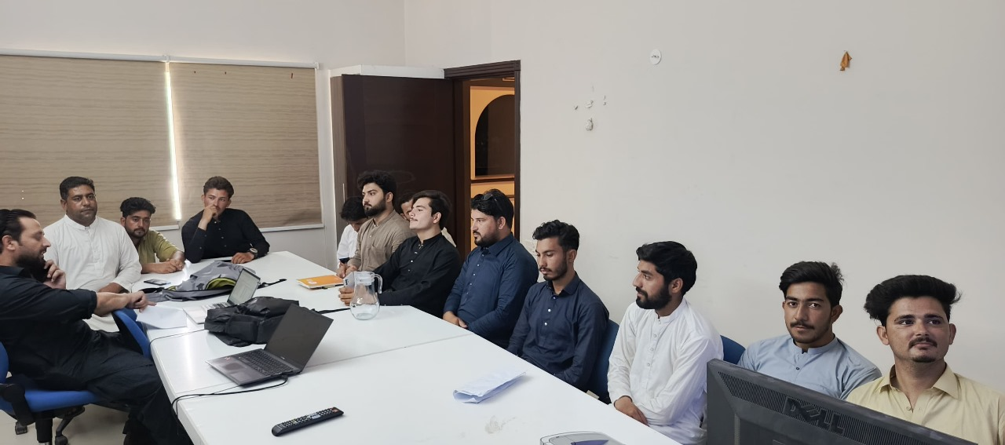
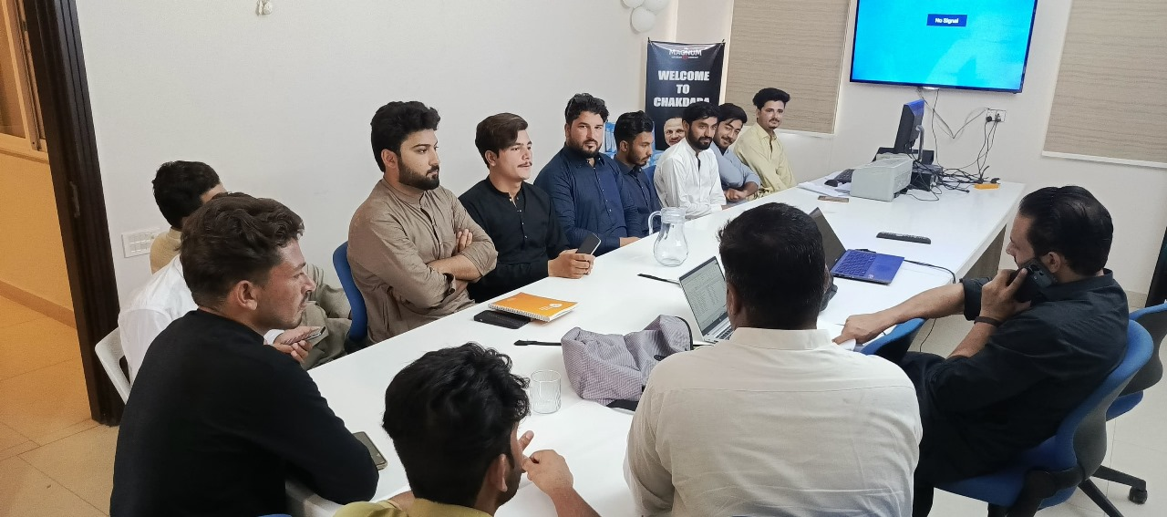

Personal Learning
The outgrowth of my 6-weeks internship in Sales & marketing Department is a comprehensive skill set that equips me to excel in the dynamic world of marketing. I have developed proficiency in market sales analysis, problem solving, customer satisfaction, Team leading, FMCG knowledge, Additionally, I responsible for both Primary and Secondary Sales , Permanent Journey Plan development and implementation, Productivity of daily planned shops to be visited, Sales Target Achievement, Supervision of distributor sales force, Order planning and stock management, Daily visits to market and taking feedback from the Retailers and Consumers, Engage retailer & RSOs to do their retail coverage , successfully introducing new products across a sales territory, Executing market communication plan for the new brands, Stock management., Target Monitoring, Screening and hiring of Order Bookers, Manage Distributor infrastructure ( ROl, Coverage, Delivery Units, Warehouse.)

Conclusion:
In conclusion, my internship experience in the sales & marketing department at Unilever wall`s has been a transformative and enriching journey. Over the period of 06 weeks, I've gained a diverse skill set from sales data analysis and this experience has not only vast my practical knowledge but has also given me a deeper understanding of the nature of sales & marketing I am grateful for the opportunities to gain experience, grow, and apply my knowledge and skills in a different organization. As I move forward in my academic and professional journey, I will carry the valuable experience and skills gained during this internship, poised to make a meaningful impact in the field of sales & marketing.

Recommendations
The following recommendations could improve the company’s operations and employee experience:
1.Additional Training for RSOs
Some Route Sales Officers appeared indifferent and interacted minimally with retailers. More frequent training on customer handling, business etiquette, and effective use of time would elevate their professional image and business performance.
2. Stock Availability
During the visits, the lack of low-cost SKUs on sale was a concern. The Company should reinforce their demand forecasting and inventory management systems to make certain the product is available on all sales routes.
3. Technology for Supervision
Though NFC scanning is already used, more comprehensive use of digital tools (smartphone apps for field reporting, geo-fenced RSO activities, and other digital real-time management tools) would improve operational clarity and the level of organization of each day's activities.
4.Intensified Engagement of Retailers
Numerous complaints were received from retailers about holding local stocks in Walls cabinets. Developing loyalty and commitment programs with retailers will encourage exclusivity and Walls commitment.
5. Focus on Dairy Production
The company should include dairy-based desserts and drinks in its product line to compete against rival companies such as Hico. This would increase the company’s revenue as well as improve Walls’ presence in the market.
6.Power Backup Solutions
Directly affecting functionality, shortages of electricity do affect freezers. The provision of freezers which are solar powered, or assistance to retailers with energy efficient solutions, helps to preserve product quality and customer loyalty.
7.Feedback Mechanism
The absence of structured feedback loops to and from RSOs and TSOs, and the administration, promotes the situation of market problems being solved too late. Fast tracking the reporting and adherence of solutions to the problems is critical.

Acknowledgment:
I would like to express my gratitude with the Core of my heart to Unilever Walls (ARCTIC ASSOCIATES) for Giving me the opportunity to undertake my internship as part of my academic curriculum. This experience gained there has been invaluable in enhancing my knowledge and practical skills in my desired field. I am deeply thankful to Sir Salman Ahmed (BDM), my supervisors, for their guidance, mentorship, and unwavering support throughout my role. Their insights and feedback have been instrumental in shaping my understanding of the subject matter. I am also grateful to the overall Team and staff of Arctic Associates for their encouragement and assistance during my Tenure. Their Commitment to fostering a conducive learning environment is commendable. This internship has a crucial milestone in my professional and academic growth, The knowledge, and skills I have gained there I aim to apply it in my future endeavors.

Personal Resume:

